**Docker and Container Internals**

1)first fork the repo

2)clone your github repo

3)create a Dockerfile

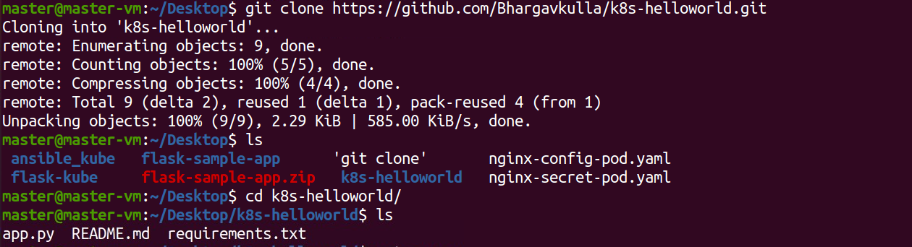

4)Build docker with docker build -t flask-app in the current directory

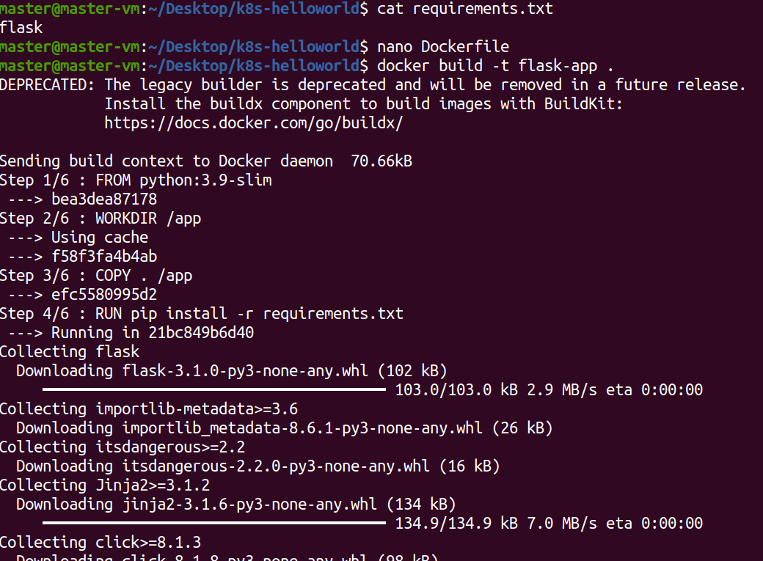

5)run the container

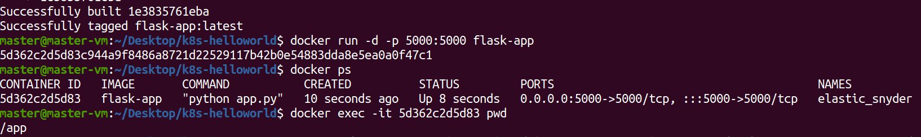

6)get working directory inside the container

7)Get read-write layer directory on the host



